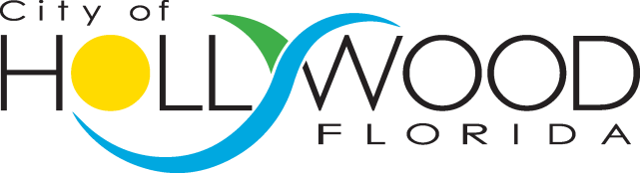
Code Compliance
GCASE
Training Session

PARKING PASS

For
Garfield Parking Garage Only
300 Connecticut Street, Hollywood

September 28, 2016
9:00 AM to 12:00 PM

