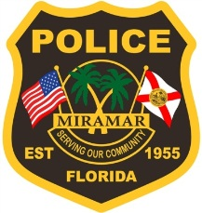
Nikki Fletcher
Detective ▪ Police Department ▪ Criminal Investigations Unit
City of Miramar ▪ 3064 N. Commerce Pkwy ▪ Miramar, Florida 33025
Administrative Hours: Monday – Thursday 7:30am – 6:00pm ▪ Friday - Closed
Tel-954.602.4131 ▪ Fax-954.602.3457 ▪ nfletcher@miramarpd.org
Serving Our Community ▪ www.miramarpd.org

Biography:

I am a police officer with the City Of Miramar. I have employed with the City of Miramar for 16 years. Eleven out of the 16 years I have been assigned to the Criminal Investigation Unit as a Detective. I have investigated a multitude of different crimes to include: shootings, robberies, child abuse, sex crimes, burglaries, frauds and various other crimes. I teach this topic (lease scams & frauds) to our police officers in our yearly training since there was a large rise in cases involving fraudulent leases and adverse possession.

